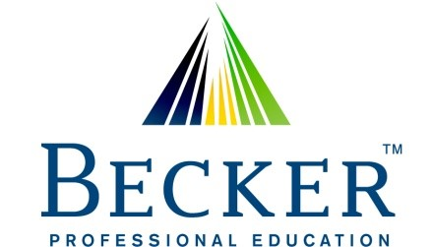
17 Hanover Road Suite 120
Florham Park, New Jersey 07932
Certificate of Completion

This certificate is presented to BHUVANESHWARAN CHANDRASEKAR
for successfully completing
SEC Update 2025 Q-2 / Audit - Whistleblower
at the following location: AT&T - Bedminster, NJ
Number of CPE credits: 1 Field Of Study: Accounting / Regulator Ethics
Delivery Method: Group Internet Based Date: 06/16/2025
In accordance with the standards of the National Registry of CPE Sponsors, CPE
credits have been granted based on a 50 minute hour.
National Registry of CPE Sponsors ID Number: 107294
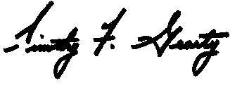
Timothy F. Gearty CPA

